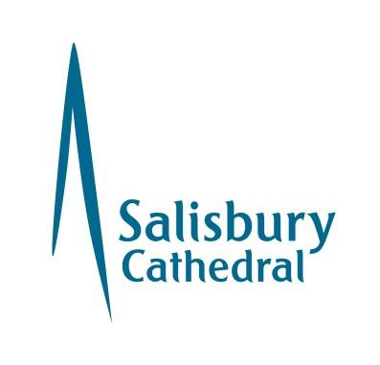
Salisbury Cathedral Youth Volunteer Application Form
Please return this form to Revd Ross Meikle (Missioner for Young People)
By post: Wyndham House, 65 The Close, Salisbury SP1 2EN
By email: youth@salcath.co.uk

Full Name
Address
Postcode
Home Telephone
Mobile (required)
Email (required)
Date of Birth
Next of Kin
with contact details
Emergency Contact
with contact details
Which Youth Volunteer role is of interest to you? Please tick.
Information about these roles can be found in your volunteer pack.
Volunteer Youth Leader
Volunteer Youth Assistant
Volunteer Youth Enabler

Information to support your application (experience, skills, faith perspectives etc)

Personal Connections
If you as a Youth Volunteer are related to or associated with a child or young person involved with a Cathedral activity, there may be a conflict of interests in allowing that child or young person to feel fully able to express themselves.
Please name any children or young people (aged 18 and under) who is a part of the Cathedral community or in attendance at Salisbury Cathedral School, and your relationship to them (i.e. parent, grandparent, godparent, family friend).

References
Please give names and addresses of two referees, making sure that they are not personal friends or family members (suitable referees will include former employers, teachers etc, or independent people who can give a view as to your experience or character).

 | Referee 1 | Referee 2
Name
Address
Telephone
Email (required)
Capacity in which you know this referee

Cautions and Convictions
The amendments to the Exceptions Order 1975 (2013) provide that certain spent convictions and cautions are ‘protected’ and are not subject to disclosure to employers and cannot be taken into account.
Guidance and criteria on the filtering of these cautions and convictions can be found on the Disclosure and Barring Service website.
Do you have any convictions, cautions, reprimands, or final warnings which would not be filtered in line with current guidance?
Yes ❑ No ❑
If yes, please give details on a separate sheet.

Safeguarding and DBS
We are committed to the safety and welfare of the people within our Cathedral. Therefore, if you are applying to work in a regulated activity with children and/or vulnerable adults and your application is accepted, it will be necessary for you to complete a Disclosure and Barring Service check.

Data Protection Act
The information that you provide on this form and that obtained from other relevant sources will be used to process your application for volunteering. The personal information that you give us will also be used in a confidential manner to help us monitor our recruitment process. If you succeed in your application and take up volunteering with us, the information will be used in the administration of your volunteering with us. We may also use the information if there is a complaint or legal challenge relevant to this recruitment process. We may check the information collected against other information held by us or with third parties. By signing this application form, you give your consent to the processing of personal data, as described above, in accordance with our registration with the Information Commissioner. If you are successful, then the information will remain on your file.

Declaration

I understand that any offer of volunteering with the Cathedral is subject to the satisfactory receipt of documentation including references and an enhanced DBS check and is binding in honour only.

In accordance with the 2018 Data Protection Act I agree that the Cathedral may hold and use personal information about me for volunteering reasons and to keep in touch with me. This information including that contained in this form can be stored on either manual or computer files. It will be held securely and only accessed by authorised personnel.
Signature
Signature:
Date:
For office use only
Interview date
Start date
Interviewer comments

Please return this form to Revd Ross Meikle (Missioner for Young People)

Wyndham House, 65 The Close, Salisbury SP1 2EN or youth@salcath.co.uk

