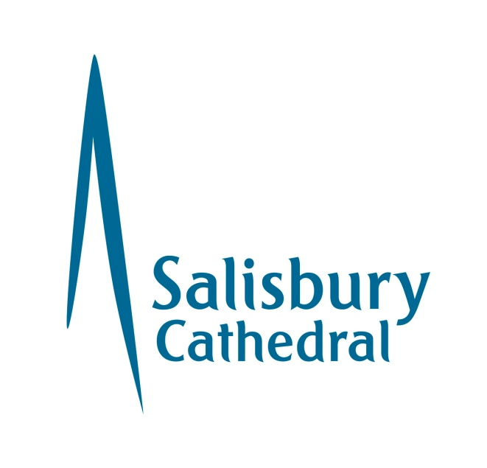

EQUAL OPPORTUNITIES MONITORING FORM

POST APPLIED FOR: ______________________________

(This form is anonymous and will be used solely for monitoring purposes and will not be available by those making the shortlisting and selection decisions. It is optional for applicants to complete and return). Salisbury Cathedral recognises and actively promotes the benefits of a diverse workforce and is committed to treating all applicants who meet the requirements advertised to be given a fair and equal consideration, regardless of race, gender, religion, disability, age, sexual orientation, gender reassignment, pregnancy or marital status. (type a ‘X’ over the box)

Gender: Female q Male q Prefer not to say [ ]

Gender Identity: Do you identify as transgender/transexual: Yes [ ] No [ ] Prefer not to say [ ]

Marital Status: Married q Single q Other q

Age Group
16 – 25 q 26 – 35 q 36 – 45 q 46 – 55 q 56 – 65 q 66+ q

Sexual Orientation
How would you describe your sexual orientation (please tick)?
Heterosexual / straight | [ ] | Bisexual | [ ] | Prefer not to say | [ ]
Gay man | [ ] | Gay woman / lesbian | [ ] | Other | [ ]

If you are lesbian, gay or bisexual, are you open about your sexual orientation?
 | Yes | Partially | No
At home | [ ] | [ ] | [ ]
With colleagues | [ ] | [ ] | [ ]
With your manager | [ ] | [ ] | [ ]
At work generally | [ ] | [ ] | [ ]

Ethnic Origin
Choose one section from (A) to (E) then tick the appropriate box to indicate your cultural background.

A. White
q British
- English
- Scottish
- Welsh
- Other, please state: ____________________________________
q Irish
q Any other white background, please state: ____________________________________

B. Mixed
q White and Black Caribbean
q White and Black African
q White and Asian
q Any other Mixed background, please state: ___________________________________
C. Asian, Asian British, Asian English, Asian Scottish or Asian Welsh
q Indian
q Pakistani
q Bangladeshi
q Any other Asian background, please state: ___________________________________

D. Black, Black British, Black English, Black Scottish, Black Welsh
q Caribbean
q African
q Any other Black background, please state: ___________________________________

E. Chinese, Chinese British, Chinese English, Chinese Scottish, Chinese Welsh
q Chinese
q Any other Chinese background, please state: __________________________________

Any other ethnic background, please state: __________________________________

q Do not wish to declare my ethnic origin

Religion or Belief

Please describe your religion or other strongly-held belief.
I would describe my religion or belief as: | __________________________________
I have no particular religion or belief | [ ]
Prefer not to say | [ ]

Disability
The Equality Act 2010 defines a disability as a "physical or mental impairment which has a substantial and long-term adverse effect on a person's ability to carry out normal day-to-day activities". An effect is long-term if it has lasted, or is likely to last, more than 12 months.
Do you consider that you have a disability under the Equality Act (please tick)?
Yes | [ ] | No | [ ]
Used to have a disability but have now recovered | [ ] | Don't know | [ ]
Prefer not to say | [ ]

Salisbury Cathedral is committed to ensuring that people with disabilities are supported and encouraged to apply for employment with Salisbury Cathedral and to achieve progress in employment with Salisbury Cathedral. This question helps us to assess our success in working towards this aim.

If you wish to provide any additional details please do so below:
_____________________________________________________________________________
______________________________________________________________________________

Thank you for your co-operation

